

HILLSIDE PRIMARY SCHOOL EXAMINATIONS BOARD

**MID TERM THREE EXAMINATIONS FOR**

**PRIMARY FIVE 2022**

INTEGRATED SCIENCE

***Time Allowed: 2 Hours 15 Minutes***

**Name**………………………………………………………..**.Stream**……………………..

|  |  |  |
| --- | --- | --- |
| **FOR EXAMINERS’**  **USE ONLY** | | |
| **Qn. No.** | **MARKS** | **EXRS’ NO** |
| **1-10** |  |  |
| **11-20** |  |  |
| **21-30** |  |  |
| **31-40** |  |  |
| **41-43** |  |  |
| **44-46** |  |  |
| **47-49** |  |  |
| **50-52** |  |  |
| **53-55** |  |  |
| **TOTAL** |  |  |

**Read the following instructions carefully:**

1. The paper has **two** sections: **A** and **B**. Section A

has **40** questions and section **B** has **15** questions.

The paper has 13 pages altogether.

1. Answer **all** questions. All answers to both

Sections **A** and **B** must be written in the

Spaces provided.

1. **All** answers must be written using a blue or black ball-point pen or ink. Any work written in pencil

other than the graphs, pictures and diagrams will **not** be marked.

1. Unnecessary changes of work may lead to **loss** of marks.
2. Any handwriting that cannot easily be

read may lead to **loss** of marks.

1. Do **not** fill anything in boxes indicated:

“**For Examiners’ Use Only**” and those inside

the paper.

**SECTION A (40 MARKS)**

1. Name the main source of water in the environment.

………………………………………………………………………………………………………………………………………………………………………………………………

2. Write P.H.C in full. ……………………………………………………………………………………………………………………………………………………………………

3. Mention any one viral childhood immunisable disease.

……………………………………………………………………………………..………………………………………………………………………………

4. Give any one dangerous object that causes cuts to the skin.

…………………………………………………………………………………

5. Why do we wash fruits before eating them?

……………………………………………………………………………………………………………………………………………………………………

6. Mention any one example of biological changes. …………………………………………………………………………………

7. The diagram below shows lifecycle of a cockroach:

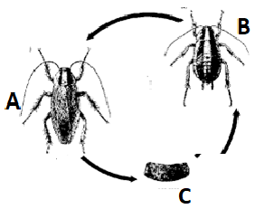

Name the stage marked B …………………………………………………………………………………

8. Identify the sense organ which enables a Primary Five pupil to watch television.

……………………………………………………………………………………………………………………………………………………………………

9. Write any one example of a root tuber. ……………………………………………………………………………………………………………………………………………………………………

10. Why should garden metallic tools be kept in dry places? ……………………………………………………………………………………………………………………………………………………………………

11. Give a reason why carbon dioxide is used in fire extinguishers.

…………………………………………………………………………………………………………………………………………………………………...

12. Name any one protective material needed when harvesting honey.

……………………………………………………………………………………………………………………………………………………………………

13. Mention any one source of food to people. ……………………………………………………………………………………………………………………………………………………………………

14. Write any one way of caring for crops in a garden.

……………………………………………………………………………………………………………………………………………………………………

15. Mention any one local way of preserving food.

……………………………………………………………………………………………………………………………………………………………………

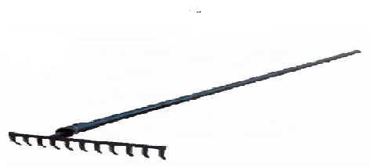16. State the use of the garden tool shown below.

…………………………………………………………………………………

17. Explain why a piece of paper is said to be matter.

……………………………………………………………………………………………………………………………………………………………………

18. Write any one basic need of sick people. ……………………………………………………………………………………………………………………………………………………………………

19. Of what importance is the tongue during food digestion?

……………………………………………………………………………………………………………………………………………………………………

20. Name any one material used by lame people to enable them move easily. ……………………………………………………………………………………………………………………………………………………………………

21. Identify any one example of a soil pollutant.

……………………………………………………………………………………………………………………………………………………………………

22. What do we call the structures on the leaves that enable it to carry out gaseous exchange? …………………………………………………………………………………………………………………………………………………………………..

23. Give one example of a solitary insect. ……………………………………………………………………………………………………………………………………………………………………

24. State any one COVID-19 message to Primary School children.

……………………………………………………………………………………………………………………………………………………………………

25. Give any one natural source of heat in the environment. ……………………………………………………………………………………………………………………………………………………………………

26. In the space below, draw an illustration of a canine tooth.

27. Suggest any one way of caring for domestic animals.

……………………………………………………………………………………………………………………………………………………………………

28. Mention any one liquid used in thermometers.

……………………………………………………………………………………………………………………………………………………………………

29. Give a reason why egg shells are porous.

……………………………………………………………………………………………………………………………………………………………………

30.How does heat from the sun reach the earth?

………………………………………………………………………………… ………………………………………………………………………………...

31. Give any one product obtained from poultry. ……………………………………………………………………………………………………………………………………………………………………

32. Mention any one organ protected by the skull. ……………………………………………………………………………………………………………………………………………………………………

33. Write any one way of getting artificial immunity. ……………………………………………………………………………………………………………………………………………………………………

34. Cite any one material people can use to harvest rain water. ……………………………………………………………………………………………………………………………………………………………………

35. Give any one way of controlling the spread of communicable diseases.

……………………………………………………………………………………………………………………………………………………………………

36. Calculate the mass of an object of density 8g/cc and a volume of 4cc.

37.Write any one way plants benefit from animals.

……………………………………………………………………………………………………………………………………………………………………

38. Mention the digestive juice produced by the liver. ……………………………………………………………………………………………………………………………………………………………………

39. In what way is calcium important in our bodies?

…………………………………………………………………………………………………………………………………………………………………...

40. Give any one way of making water safe for drinking. ……………………………………………………………………………………………………………………………………………………………………

**SECTION B (60 marks)**

41. The diagram below shows a part of a flower. Use it to answer questions that follow:

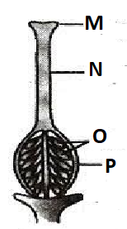

1. Identify the part of the flower drawn above. …………………………………………………………………………………………………………………………………………………………

b) Name the parts M and P.

i) M ………………………………………………………………………………..

ii) P……………………………………………………………………………..

c) What does part **O** develop into after fertilization?

……………………………………………………………………………………………………………………………………………………………….

42. a) Mention any two examples of chemical changes.

1. ………………………………………………………………………….
2. ………………………………………………………………………….

b) Write any one characteristic of physical changes

……………………………………………………………………………………………………………………………………………………………..

c) State one physical process involved in rain formation.

……………………………………………………………………………………………………………………………………………………………...

43. a) What are disease vectors? ………………………………………………………………………………………………………………………………………………………………

b) Name any two examples of disease vectors.

i) …………………………………………………………………………….....

ii) ………………………………………………………………………………

c) Write any one way of controlling the spread of malaria.

………………………………………………………………………………………………………………………………………………………………

44. a) What is mulching?

……………………………………………………………………………… ………………………………………………………………………………

b) Identify any two materials used for mulching.

i) ………………………………………………………………………………

ii) ………………………………………………………………………………

c) Mention any one advantage of mulching. ………………………………………………………………………………………………………………………………………………………………

45. Two objects, a stone and a tin when dropped in water and they settle as shown below:

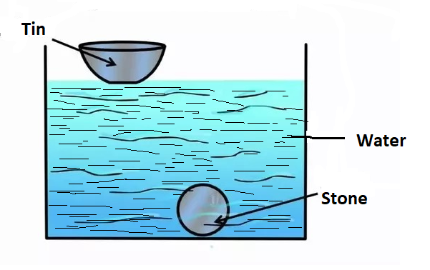

1. What scientific term describes the behavior of;
2. A stone?

………………………………………………………………………………

1. A tin?

………………………………………………………………………………

1. Name any one liquid that can behave like the tin if poured in the water.

……………………………………………………………………………….

d) Why does the stone go at the bottom when dropped in water? ……………………………………………………………………………….

46. a) Mention any one activity a P.5 pupil can do to promote Primary Health Care.

………………………………………………………………………………………………………………………………………………………………

b) Name any two elements of Primary Health Care.

i) ……………………………………………………………………………

ii)……………………………………………………………………………

c) Give one way physical exercises are useful to a P.5 pupil

………………………………………………………………………………………………………………………………………………………………

47. a) How are these crops propagated?

i) cassava

………………………………………………………………………………

ii) Carrot

………………………………………………………………………………

b) Suggest any one method you would use to keep soil fertile.

……………………………………………………………………………….

c) Mention one plant whose seeds are first planted in a nursery bed.

………………………………………………………………………………………………………………………………………………………………

48. The chart below shows composition of air in the atmosphere. Use it to answer the questions that follow.

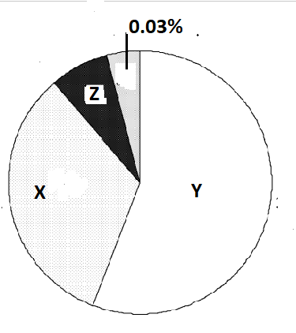

a) Identify the gas which occupies 0.03% as shown above.

………………………………………………………………………………………………………………………………………………………………

1. State the percentage of the gas marked Y on the diagram

………………………………………………………………………………………………………………………………………………………………

1. Name any one process which uses gas X

………………………………………………………………………………………………………………………………………………………………

1. What term is used to describe moving air?

………………………………………………………………………………………………………………………………………………………………

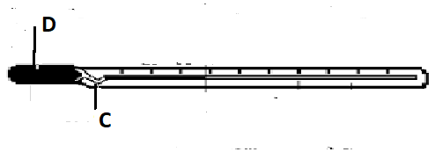49. The diagram below shows a clinical thermometer.

1. Name the liquid found at D.

......................................................................................................................................................................................................................

1. How is part C important in a clinical thermometer?

……………………………………………………………………………………………………………………………………………………………………

1. List two body parts where the above instrument is put while recording temperature.
2. ……………………………………………………………………………….

ii)………………………………………………………………………………

50. a) Identify the part of a mushroom which produces spores.

……………………………………………………………………………………………………………………………………………………………………

b) Apart from a mushroom, name other two examples of fungi.

i) ……………………………………………………………………………..

ii) ………………………………………………………………………………

51 a) what is dehydration? ………………………………………………………………………………………………………………………………………………………………

b) Write any two cause of dehydration.

i) ……………………………………………………………………………

ii) ……………………………………………………………………………

d) Name one solute used to prepare ORS locally at home.

……………………………………………………………………………………………………………………………………………………………………

52. The diagram below shows part of a thermos flask. Use it to answer questions that follow:

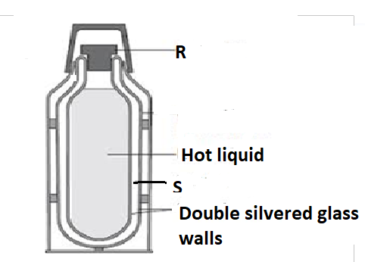

1. Name the part marked R

………………………………………………………………………………

1. Why are the walls of a vacuum flask silvered?

………………………………………………………………………………

1. Of what value is this equipment in our home?

………………………………………………………………………………

1. Write any one use of heat to people.

………………………………………………………………………………

53. a) Mention any two materials we use to clean our teeth

1. ……………………………………………………………………………….

ii)……………………………………………………………………………

b) Why do we brush our teeth after every meal?

………………………………………………………………………………………………………………………………………………………………

1. State the function of teeth during digestion

..............................................................................................................

54. a) Identify the type of weather suitable for drying harvested cereals.

………………………………………………………………………………..……..…………………………………………………………………………

b) Mention any one item a P.5 pupil needs to have when walking in rain.

……………………………………………………………………………………..…………………………………………………………………………

c) Write any two dangers that are caused by strong wind.

i)…………………………………………………………………………

ii)…………………………………………………………………………

55. Match the following correctly:

**Enzyme**  **Action**

Rennin digests cooked starch

Salivary amylase works on fats and oils

Lipase changes proteins into peptides

Pepsin clots milk proteins

**CORRECT ORDER**

1. Rennin………………………………………………………………..
2. Salivary amylase …………………………………………………..
3. Lipase…………………………………………………………………
4. Pepsin…………………………………………………………………

END